Kit List – What to wear for Forest School
It is important that participants are dressed for the weather so that they are comfortable and can enjoy their time in the woods. Please wear old clothes that can get dirty / muddy. Learning happens best when children are relaxed, and we don’t want them to be worried about getting their best trousers dirty!
A large re-usable carrier bag to put wet waterproofs in at the end of the session, and a bin bag to cover your car seat might be a good idea.
What to wear in mild weather:
- Long sleeved cotton top (we recommend long sleeved tops and trousers all year round to help protect against scratches and insect bites)
- Comfortable trousers – leggings or jogging bottoms are ideal.
- Fleece jumper
- Two pairs of socks
- Waterproof coat
- Waterproof trousers
- Sturdy closed-toe shoes or wellies

What to wear in hot weather:
- Thin long-sleeved cotton top
- Comfortable trousers – leggings or jogging bottoms are ideal
- One pair of socks
- Jumper or jacket, waterproof coat and trousers in a bag in case weather changes
- Sun hat
- Sun cream (labelled with child’s name)
- Sturdy closed toe shoes or wellies:

What to wear in cold weather:
- Please use the ‘Cold Gear Sheet’ below to guide your cold weather clothing choices

Footwear:
Wellies are very waterproof and great for jumping in puddles, but they are very cold and can be slippery when climbing. If wearing wellies, two pairs of socks are recommended – one thin cotton pair and one thick bed-sock type pair, along with fleece welly warmers. Neoprene-lined wellies are warmer. Waterproof walking shoes/boots are ideal for Forest School.
Dressing for Forest School … keeping warm in the winter time
Layers, layers, layers! Lots of thin layers are far better than fewer thick ones, as each layer traps air for insulation. If they get too hot, children can easily remove layers, but they find it hard to warm up once cold. Natural materials such as wool are the best for warmth. Wellies are great for puddles but very cold…go for neoprene lined wellies, or waterproof walking boots… if wearing wellies, wear several pairs of socks and fleece welly warmers.
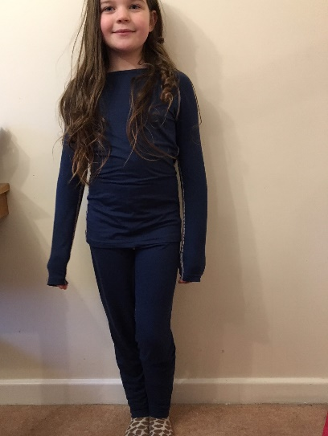  Layer 1: Base layers: thin leggings and long sleeved top. Thin socks. | 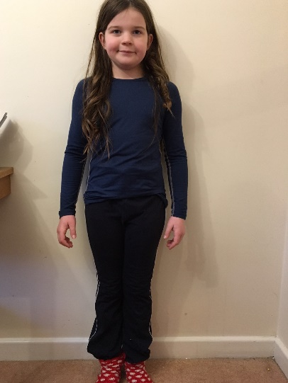  Layer 2: Jogging bottoms and thick socks | 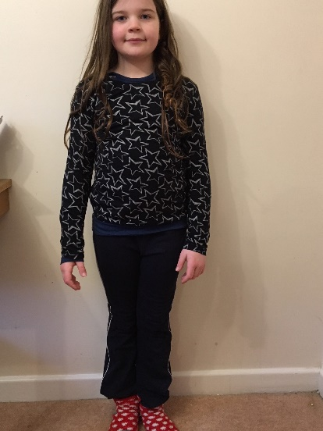  ..and thin long sleeved cotton top
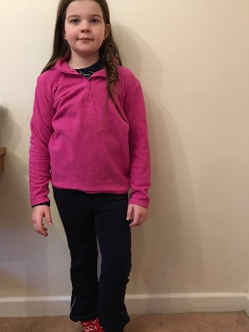  Layer 3: Thin fleece jumper | 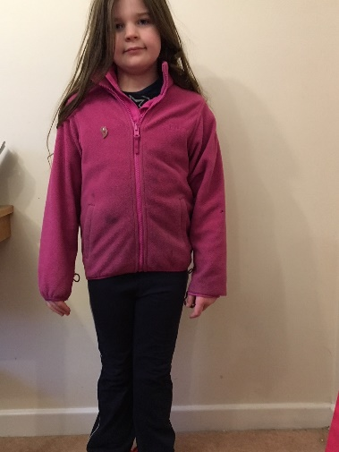  Layer 4: Thick fleece | 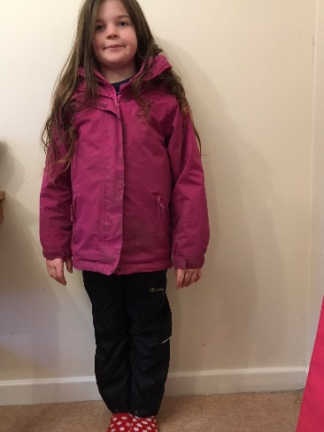  Layer 5: Waterproof coat and trousers
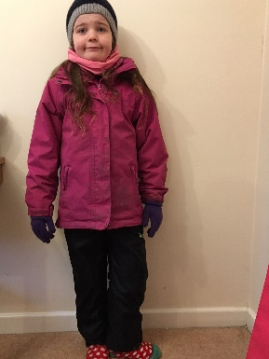  Hat, gloves and snood. | 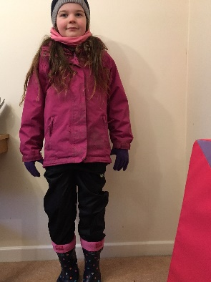Welly warmers and wellies (or walking boots) … and ready to play!

