Dressing for Forest School … keeping warm in the winter time
Layers, layers, layers! Lots of thin layers are far better than fewer thick ones, as each layer traps air for insulation. If they get too hot, children can easily remove layers, but they find it hard to warm up once cold. Natural materials such as wool are the best for warmth. Wellies are great for puddles but very cold…go for neoprene lined wellies, or waterproof walking boots… if wearing wellies, wear several pairs of socks and fleece welly warmers.
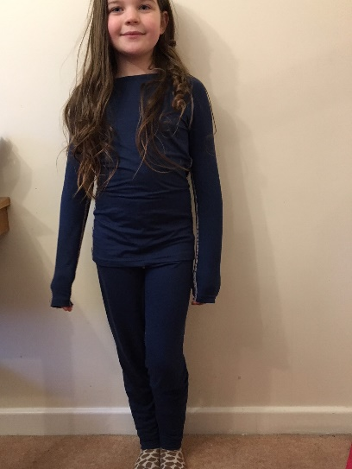  Layer 1: Base layers: thin leggings and long sleeved top. Thin socks. | 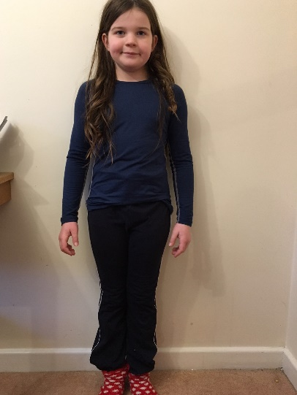  Layer 2: Jogging bottoms and thick socks | 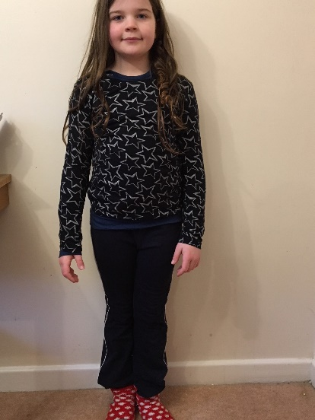  ..and thin long sleeved cotton top
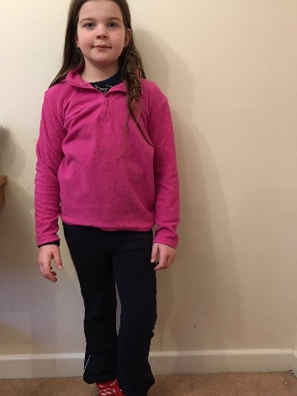  Layer 3: Thin fleece jumper | 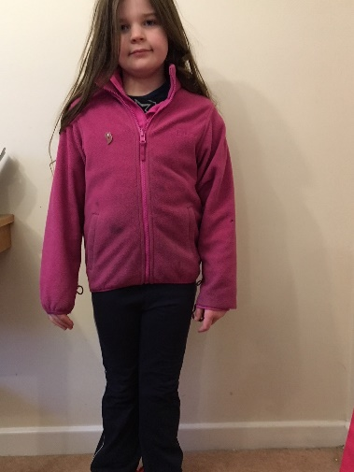  Layer 4: Thick fleece | 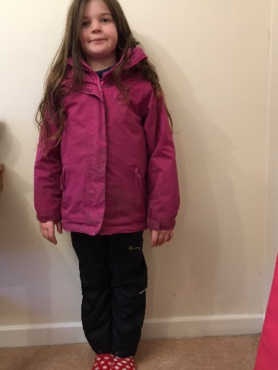  Layer 5: Waterproof coat and trousers
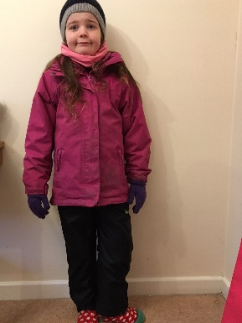  Hat, gloves and snood. | 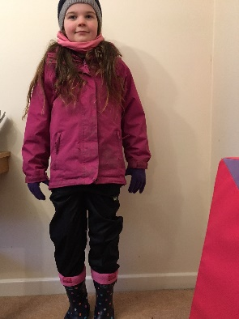Welly warmers and wellies (or walking boots) … and ready to play!

